Info

Test designer: Alexandre Guilbault
Creation date: 04/04/2019
ID Jira: SEC-384
Test Title: Pioneer Navigation

Test description

Test objectives and goals:
Validate the navigation on the pionner with the integration of the yocs_velocity_smoother node and with the modification to the RoboClaw node.

Sub-system(s):
Navigation

Component(s) (devices and test equipment):
-Pioneer with Jetson TX2
-Roboclaw
-RP-Lidar
-Intel Realsense d435
-Laptop

Environment (location, conditions):
P2-1033, P2-1004 → Lab environnement at the 3it

Test Procedure (include files and illustrations):
To perform the test, RTAB-Map needs a map. See test Pioneer-Mapping_SEC-335.rtf to create a map.
Test performed with the branch SEC-335-Pioneer-Setup-ROS, with the commit edc3337

- Unplug lidar usb under pioneer top on left side
- Remove the top of the pioneer (2 screws with an allen key)
- Power up the electronic by plugging the EC5 connector in the orange battery
- Install back the top of pioneer (2 screws with an allen key)
- Plug in lidar under pioneer top on left side
- Power on Jetson (power button reachable trough hole on pioneer right side

[On Pioneer]
$ roscore
(other tab)
$ roslaunch securbot_pkg localization.launch
(other tab)
$ roslaunch securbot_pkg navigation.launch

[On Laptop]
$ roscd securbot_pkg/launch
$ rosrun rviz rviz -d navigation.rviz

- Manipulations:
1) Position the pioneer in the P2-1033 so it looks at the door to help it find itself in the map.
2) Using RVIZ, send the pioneer to different locations in the P2-1033.
3) Using RVIZ, send the pioneer in the corridor.
4) Using RVIZ, go in the P2-1004. (The door should be open)
5) Using RVIZ, go to the washrooms near the clean rooms.
6) Using RVIZ, go to the end of that corridor.
7) Using RVIZ, come back to the P2-1033.

Test parameters and inputs (limits, tolerances, settings):
Inputs are the position in RVIZ.

Parameters are the navigation parameters in the following files:
base_local_planner_params.yaml
global_costmap_params.yaml
costmap_common_params.yaml
local_costmap_params.yaml
smoother.yaml

They are located in ~/catkin_ws/src/Robot_Software/securbot_pkg/config.

Expected results:
1) The pioneer should reach the desired location and orientation without any collision.
2) The pioneer should reach the desired location and orientation without any collision.
3) The pioneer should reach the desired location and orientation without any collision.
4) The pioneer should reach the desired location and orientation without any collision.
5) The pioneer should reach the desired location and orientation without any collision.
6) The pioneer should reach the desired location and orientation without any collision.
7) The pioneer should reach the desired location and orientation without any collision.

Security

Potential risks:
[ YES / NO ] Mechanical equipment damages (high speeds, sharp objects, projectiles)
[ YES / NO ] Electrical equipment damages (high power, reverse polarity, ESD, shorts)
[ YES / NO ] Thermal hazards (power dissipation, friction, heat-sensitive/flamable components)
[ YES / NO ] Chemicals (batteries, contaminants, exposition, airborne particles)
[ YES / NO ] New components (first tests, original/student designs)
[ YES / NO ] Human risks (operator proximity, ergonomics, environment, bystanders)
[ YES / NO ] Others: _______________________________
___________________________________________________
___________________________________________________

Risk mitigation:

Neutralization at the source:
The pioneer should always be on the ground when it is powered on.

Collective protections:
Someone from the team has to follow the robot to ensure it does not endanger itself or bystanders.

Personal protections:

Approbation

Approved by: ______________________
Date: ________________________

Test Results

Test 1 : Alexandre Guilbault, April 10th 2019
First complete test with the pioneer
Results & Comments
When moving around the lab, the robot has a hard time avoiding chairs, since their shape is not the same at the height of the lidar as on the ground. Therefore, the obstacle detected by the lidar is not the right size, which leads in a collision.

To avoid this problem, we need to use the RGBD camera to detect obstacles. Feeding the point cloud directly to the local costmap resulted in weird obstacles being detected, especially when the robot is turning on itself. The next step was to feed the obstacle detected by RTAB-Map (rtabmap_ros/obstacles_detection) to the local costmap.

With this setup, there is a definite improvement in the detection of chair legs.

%%% Pictures before and after

Test 2 : Alexandre Guilbault, April 12th 2019
This test was used as the video demonstration of the project (For the end of the winter semester)
Results & Comments
Two main navigation problems were identified during this test.

First of all, the global costmap tends to see obstacles that are not there, which prevents the global planner from finding a path to a far away goal.

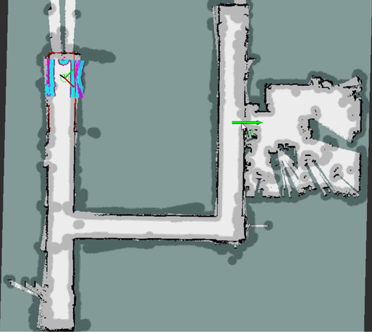
In this picture taken during the test on Rviz, we see that the global obstacles (dark grey) sometimes block the entire hallway, even if nothing was there. The lidar measurements seem to be affected by some imprecision when the robot is turning, which make it seems like the walls corners are not at the right place when they are far away from the robot.

No step as been taken at this moment to solve the problem (see test 4)

The second problem occurs when a goal is set once again far away from the robot. The map generated by the robot has some imperfections, which means the global planner finds path outside of the map.

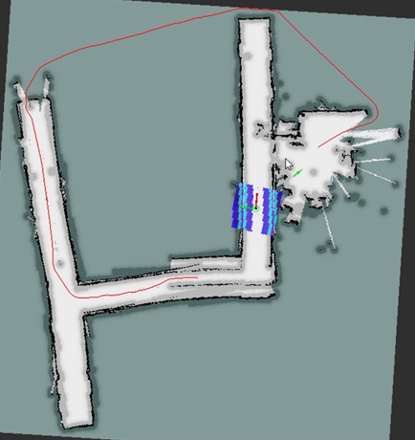
No step has been taken at this moment to solve this problem (see test 3)

Test 3 : Alexandre Guilbault, April 16th 2019
This test objective is to show that the robot no longer plans path outside of the map. To do so, the parameters of the global planner were updated by changing the value of the parameter allow_unknow to false in move_base (name of the plugin is NavfnROS)
Results & Comments
The change had no effect. As per the documentation on the global planner, a change must also be done in the costmap. The parameter track_unknown_space must be set to true in the global_costmap plugin of move_base.
This change effectively prevents the robot from planning a path outside of the map.

Test 4 : Alexandre Guilbault, April 18th 2019
The goal of this test is to optimize the navigation parameters of the pioneer to improve global path planning and confirm that the global planner does not plan paths outside of the map.

Results & Comments
A new map was made for this test, by doing multiple passes in each corridor to ensure RTAB-Map finds plenty of features to localize itself in the map when it is navigating.

To prevent the problem seen in the test #2, where obstacles would be added to the global costmap without actually being there. Rviz showed these obstacle were seen by the lidar at long range, so we removed the lidar from the sources of the global costmap in the global_costmap_params.yaml file.
For the lidar, raytrace distance is set to 25m and obstacle range to 10m.
For the pointcloud, raytrace distance is set to 10m and obstacle range to 4m.

With these parameters, mapping and planning works great. However, the robot is not able to avoid an obstacle if it is in its planned path. It just stops.

The first step to avoid this problem is reducing the pdist parameter of TrajectoryPlannerROS. There is no change observed in the behavior of the robot.

The lidar is added back to the global costmap obstacle source, but its obstacle detection range is set to 3m (only for the global costmap).
This changes allows the robot to avoid moving people quite well.

Another challenge is entering in the lab through the door. To help it see the doorway, the local costmap is increased to 5mx5m.
This changes makes thimgs worse, because the pointcloud detects false obstacle everywhere.

The obstacle range of the pointcloud is reduced to 2m.
The local costmap is reduced to 3mx3m.

The door is better, but not perfect.

The robot stay near its obstacle when navigating.
The obstacle inflation is increased to 1m.
The robot now moves at the center of the corridor and does a better job at avoiding people.

The robot does not follow its path.
Gdist parameter of TrajectoryplannerROS is put back to 0.8.
Avoids people and follows its path.

Robot is neat my feet when avoiding me.
Increasing occdist parameter of TrajectoryPlannerROS to 0.01.
Does a better job at avoiding.

Overall, the pionner works now better than ever and has no major problem.
The only difficulty is going through the door.
We might want to allow a faster deceleration so it brakes if someone jumps in front of it.

__________________________________________________

